Project Overview & Objectives The Grade Management System provides a streamlined way to track student academic performance. The objective was to implement Week 2 concepts: nested loops, switch menus, arrays for data storage, and try-catch error handling.
Setup and Installation
- Prerequisites: Java 11 or higher.
- Installation: Download the source files into a src directory. Open the command line, run javac *.java to compile, and java GradeManagementSystem to execute.
Code Structure Explanation The application uses a separated architecture for maintainability:
- GradeManagementSystem.java: Handles the while loop menu, Scanner interactions, and input validation.
- StudentGrade.java: The primary data model. Stores the student name as a String and their marks as a double[] array.
- GradeCalculator.java: Contains static math methods. Segregating this makes the calculation logic easy to test.
- ReportGenerator.java: Handles the nested loops required to iterate over the ArrayList of students and their inner arrays of marks to calculate class-wide statistics.
Visual Documentation (Take screenshots of your terminal running the code and place them here)
Adding a student and triggering the 0-100 validation error
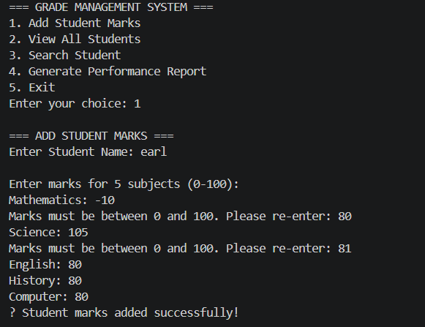

Viewing the tabular student data
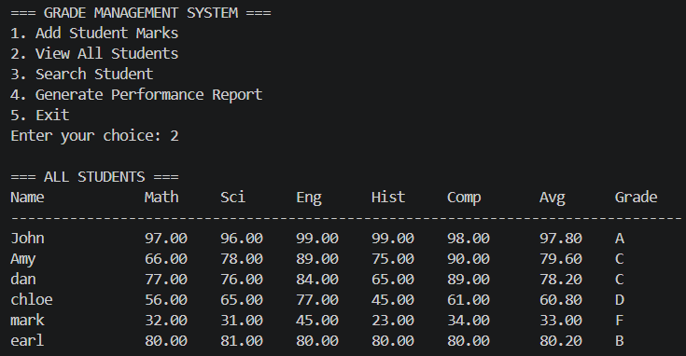
Viewing the generated Performance Report
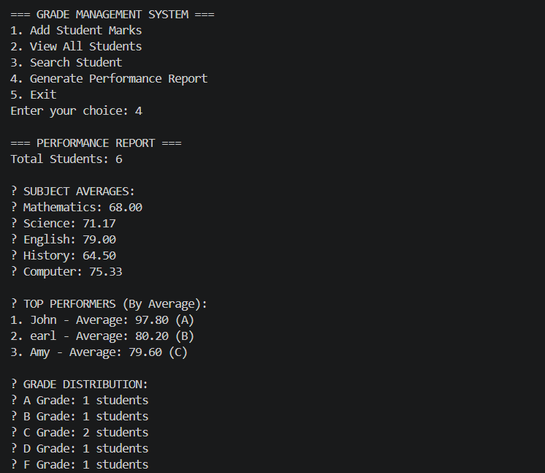
Technical Details
- Data Structures: Used an ArrayList<StudentGrade> to hold the student objects, but used primitive double[] arrays inside the objects to hold the specific subject marks. This satisfies both dynamic scaling and strict array usage.
- Control Flow: Utilized enhanced for-each loops for reading data, standard for loops for indexed arrays, and a while(true) loop to handle persistent prompt validation.
- Error Handling: Integer.parseInt and Double.parseDouble inside try-catch blocks catch NumberFormatExceptions, preventing app crashes when users type letters instead of numbers.

Testing Evidence
- Validation Test: Entered -10 and 105 for marks. System rejected both and prompted for re-entry. Entered abc for a mark; system caught the exception and requested a valid number.
- Calculation Test: Input marks 90, 90, 90, 90, 90. System correctly calculated average as 90.00 and assigned Grade "A".
- Report Sorting Test: Added Alice (Avg 85), Bob (Avg 95), and Charlie (Avg 70). Report correctly listed Bob as #1, Alice as #2, and Charlie as #3.

